Ridgid Impact Driver/Drill
Training Manual

Table of Contents
Intro 2
Product Overview 2
Changing out a drill bit 4
Changing the drill’s battery 5
Fixing a broken, wooden fence post 6
Hanging a picture 7
Removing a tire 8
Drilling a pilot hole 9
Installing a striker plate 10
Removing a vent cover 11
Tips 12

Intro

Hello, handyman! Congrats on the new job at This guide will help you learn to use your new Ridgid impact driver/drill by teaching you to change its bits as well as its battery. These two things are crucial tasks for a handyman owning this impact driver/drill, so it is important that you know how to perform these tasks well. In addition to these simple tasks, you will also learn to fix a wooden fence post, hang a picture, remove a tire, drill a pilot hole, install a striker plate, and remove a vent cover.

Product Overview

The Ridgid impact driver/drill is essentially the 21st century’s extreme version of a screwdriver. The drill has a brushless internal design and a durable rubber exterior to safety and comfort. It is equipped with a belt clip to allow for carry without having to hold it. There is a speed switch at the top to allow for three different speeds, designed for different tasks. Level one is slow, but allows for much more torque. There are forward and reverse buttons for any task at hand. The universal bit slot at the front of the drill allows for any type of bit and nearly any size bit to be used. You can transform the tool drastically by placing different bits into the bit slot. The drill also includes LED lights near the bottom for work in dark areas. Not only can it do everything a screwdriver can do, but it can do so much more, like allow you to fix a tire, drill pilot holes for large pieces of wood, cut holes out of any material, and ratchet down bolts. It can even be used as a flashlight and a router. This piece of equipment is essential for a handyman as it is so versatile. Nearly every task can use one of its features, so it is a good thing the drill is so durable and reliable.
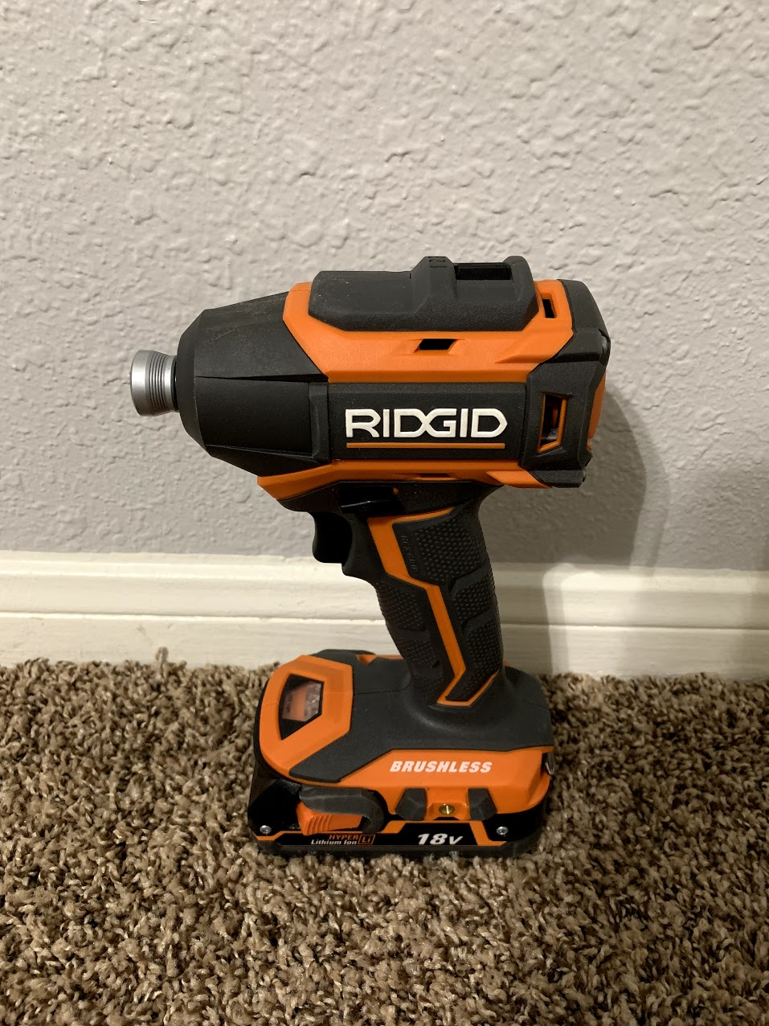
6
5
4
1
3
2
1 | Speed Control Switch | Controls how fast the bit slot turns
2 | Bit Slot | Spins; allows bits to be inserted
3 | Reverse button/Forward button | Changes the direction the bit slot turns
4 | Trigger | Turns the drill on and off
5 | LED lights | Provide light for work in dim or no light
6 | 18 Volt Rechargeable Battery | Powers the drill

Changing out a drill bit

This is a common task that every drill owner needs to know. Being able to do this will help you use any attachment for your drill.
- Hold the drill in such a way that you can keep the drill steady, and place the thumb and index finger of your non-dominant hand on the bit slot at the same time.
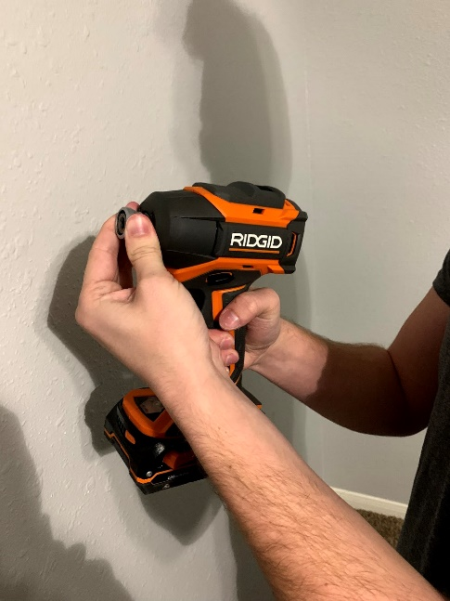
- Pinching the bit slot with your thumb and index finger, pull it away from the drill.
- Grab the bit that is in the drill, and pull it out.
- Release the end of the bit slot.
- Choose the bit you want to use.
- Push the end of the new bit that looks like the inside of the bit slot into the opening.
Congratulations! You have successfully changed your drill bit! Now you can conquer any task that requires a new bit.

Changing the drill’s battery

Your impact driver/drill needs juice to work, and you will need to change its battery eventually so that you can keep using it.
- Hold the drill firmly with your dominant hand.
- With your other hand, depress the orange buttons on both sides of the battery with your thumb and middle finger.
- Pull the battery away from the drill while keeping the drill steady with your dominant hand.
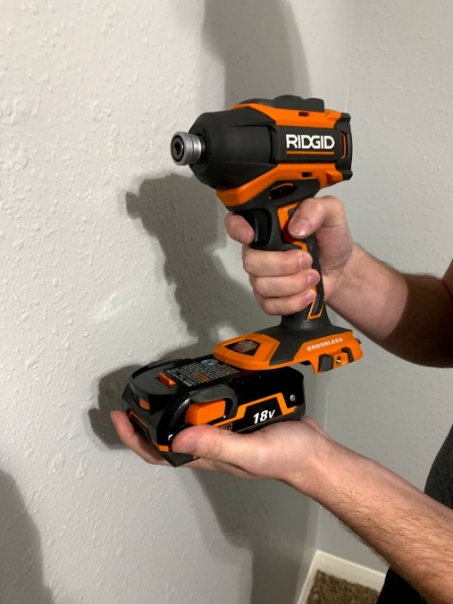
- Choose the battery you want to use with your drill.
- Without depressing the orange buttons on the new battery, slide it onto the bottom of the drill while using your dominant hand to steady the drill.
Congratulations! Now you know how to change your drill’s battery.

Fixing a broken, wooden fence slat

Fixing fences is a common job for a handyman. Wooden fences are often in disrepair, so knowing how to fix one is important.
- Locate the broken fence slat.
- Fully depress the reverse button, and set the drill speed switch to 2.
- Locate the screws in the broken fence slat.
- Place the drill tip into a screw on the broken fence slat until it is fully inside, and pull the trigger of the drill to remove the screw.
- Repeat step 5 with all remaining screws in the broken fence slat until it is removed from the fence.
- Place the new fence slat in the empty spot created by the broken fence slat.
- Fully depress the forward button, and set the drill speed switch to 2.
- Use the screws taken out of the broken fence post to attach the new fence slat by drilling the screws into their previous positions, gently applying pressure to each screw.
Great! Be sure to remember this procedure the next time you need to fix another slat.

Hanging a picture

Eventually, you will need to hang a picture. This procedure will help simplify the process.

- Locate the spot where you want to hang the picture.
- Fully depress the forward button, and set the drill speed switch to 2.
- Place the tip of a screw onto the spot where you want to hang the picture, and push it slightly into the surface while still holding it there.
- Place the bit of the drill into the face of the screw.
- Pull the trigger slowly and gradually increase the drill’s speed while gently pushing into the screw.
- Drive the screw into the surface until it sticks out about a quarter of an inch.
- Place the picture onto the wall, allowing the frame’s wire to grab the screw and hang from it.
- Reposition the picture as needed.
Congrats, you hung a picture. That wasn’t so hard.

Removing a tire

It is a valuable skill to be able to change a tire. Handymen will often have to do this since they work with machinery a lot.
- Position yourself in front of the tire you want to change.
- Place the bit that matches the bolts’ heads on the tire in the bit slot.
- Fully depress the reverse button, and set the drill speed switch to 2.
- Place the drill in front of one of the sockets, allowing the bit to completely cover the bolt’s head.
- Pull the drill’s trigger until the bolt is removed.
- Repeat steps four and five for each bolt on the tire.
- Grab the tire at two opposite points.
- Pull the tire toward you, away from the axle.
Well done! The tire is now removed.

Drilling a pilot hole

In order to use screws in wooden boards that are in danger of cracking, you need to drill a pilot hole before you drill the screw. Pilot holes are also useful with other materials and surfaces, like metal, which do not allow a screw or bolt to easily go through.
- Locate the spot where you want to drill a pilot hole.
- Mark the spot with a pencil.
- Determine which drill bit is best for the size of the pilot hole.
- Place the chosen bit into the bit slot of the drill.
- Position the tip of the bit on the point that you marked with a pencil.
- Press into the mark gently.
- Pull the trigger of the drill gradually until it is at full speed, still pressing gently into the surface.
- Remain steady and keep holding the trigger until you feel the bit push through the surface entirely.
- Pull the drill away from the surface while holding it straight.
Congrats! You have successfully drilled a pilot hole, and you are ready to drill the screw.

Installing a striker plate

Whenever you install a door, you will also need to install a striker plate so that the door can properly close. This is an easy procedure, as striker plates do not have many screws.
- Locate the doorway where you want to install a striker plate.
- Locate your new striker plate.
- Place a pilot drill bit into the bit slot of your drill.
- Depress the forward button fully on the drill.
- Hold the striker plate in the slot of the inside of the door frame where the doorknob lines up.
- Using the holes in the new striker plate as a guide, drill two pilot holes into the inside of the door frame.
- Replace the pilot drill bit in your drill with a Philips bit.
- Holding the new striker plate in place, drill two Philips screws into the holes you previously created.
- Properly tighten the screws.
Congrats! Your striker plate is installed, and the door will stay in place when closed.

Removing a vent cover

Before cleaning a vent cover, you should remove it from the vent.

- Place the bit that matches the screw heads of the vent cover into the bit slot.
- Ensure the reverse button is fully depressed on the drill.
- Place the bit on the head of one of the screws.
- Pull the trigger gently until the screw is removed.
- Repeat step five with the remaining screw.
Now you can easily clean the vent cover.

Tips

Below are some tips that will help you properly use your Ridgid impact driver/drill as well as your drill bits.
- To check how much charge an 18 Volt Ridgid Battery has left, press the battery indicator button on the front of the battery.
- Your Ridgid impact driver/drill is built to last, so you do not have to worry about being gentle with it.
- When pulling out the bit slot, be careful. Some bits have a tendency to shoot out of the end. To decrease the risk of losing a bit, insert and remove bits over a flat, clean surface.
- When drilling screws into anything, be careful not to overtighten the screws. Your Ridgid impact driver/drill is very powerful and can ruin products and screws if they are tightened too much. In the same regard, make sure that screws and bolts are not too loose.

